**Spring Data JPA – Hands‑on 1 Documentation**

**Database Setup (MySQL 8.0 / Workbench)**

Commands executed:

CREATE SCHEMA ormlearn;

CREATE TABLE country (

co_code VARCHAR(2) PRIMARY KEY,

co_name VARCHAR(50)

);

INSERT INTO country VALUES ('IN', 'India');

INSERT INTO country VALUES ('US', 'United States of America');

**Application Configuration:**

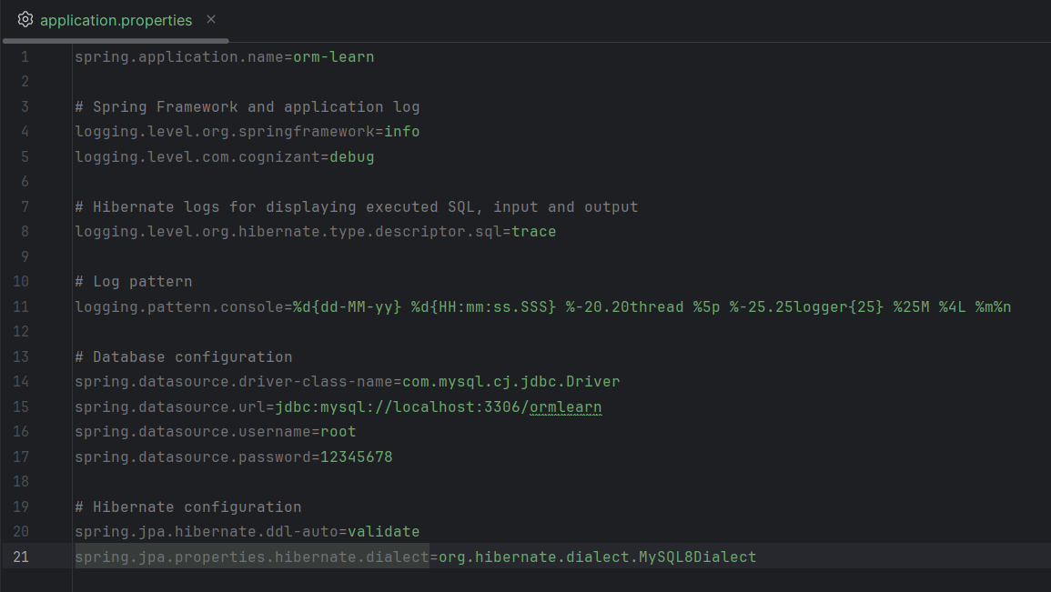

**JPA Entity :**

**Country.java**

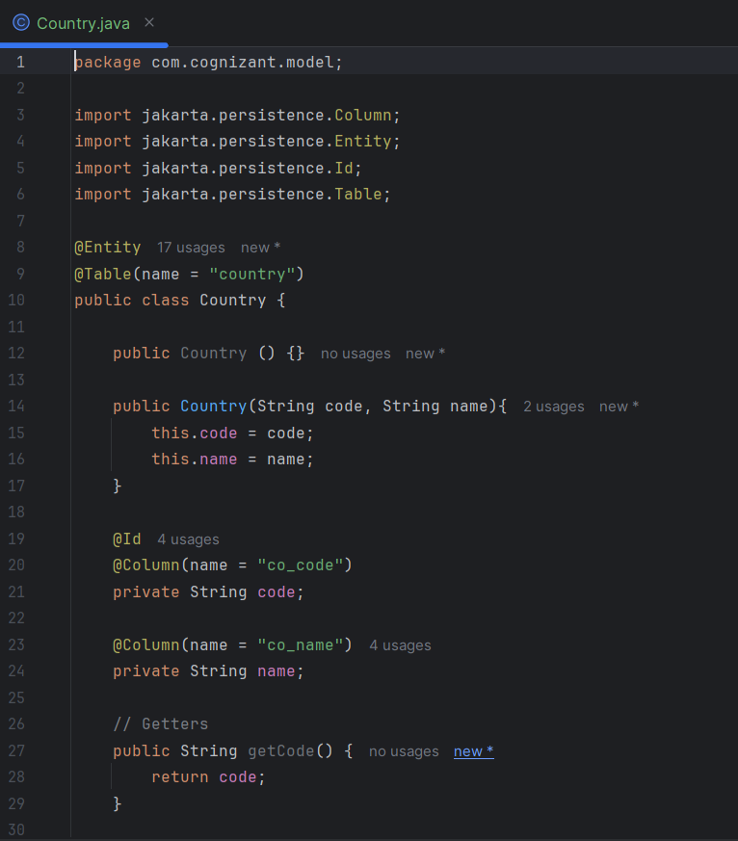

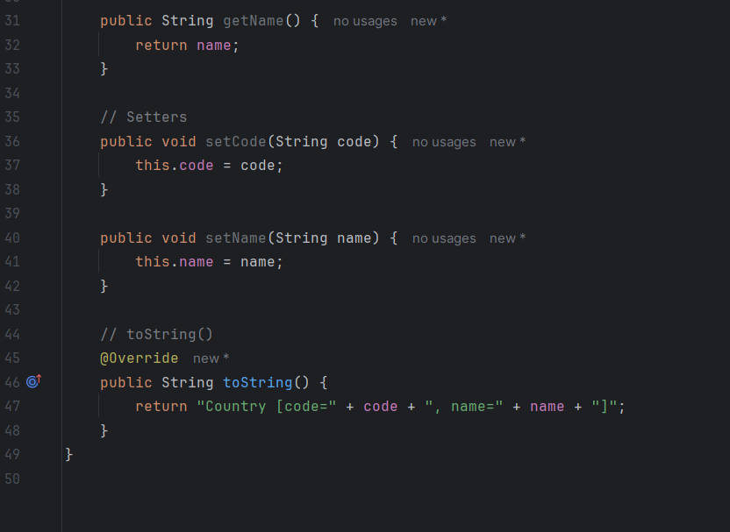

**Repository Interface:**

**CountryRepository.java**

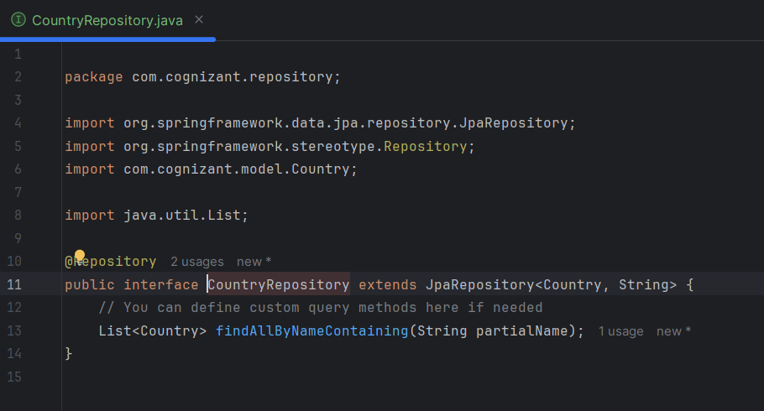

**Service Layer :**

**CountryService.java**

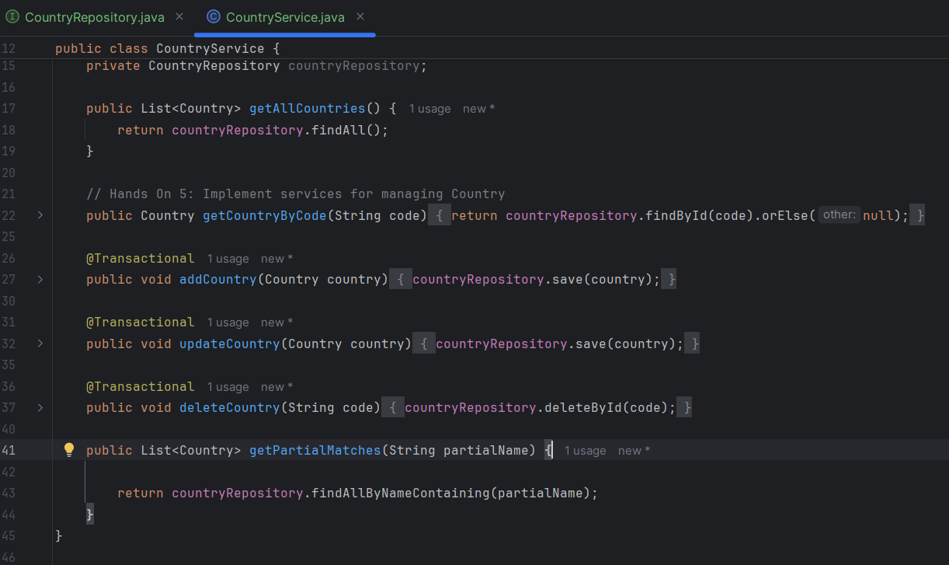

**Main Application:**

**OrmLearnApplication.java**

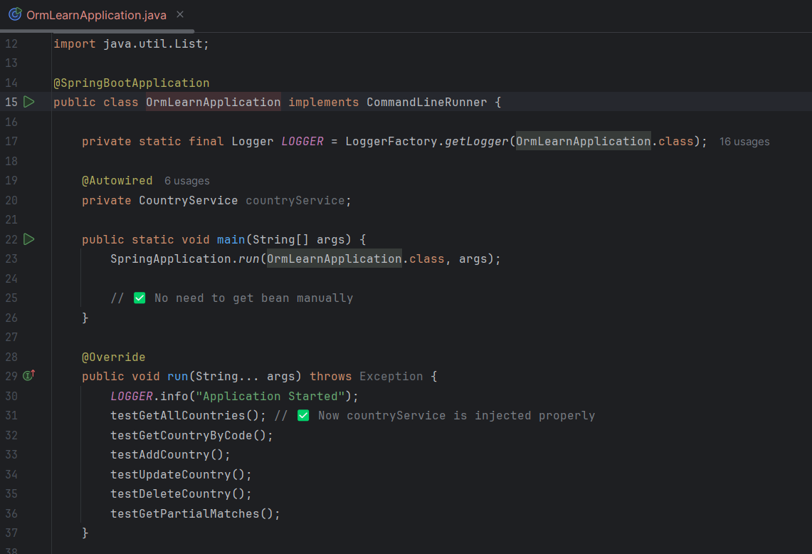

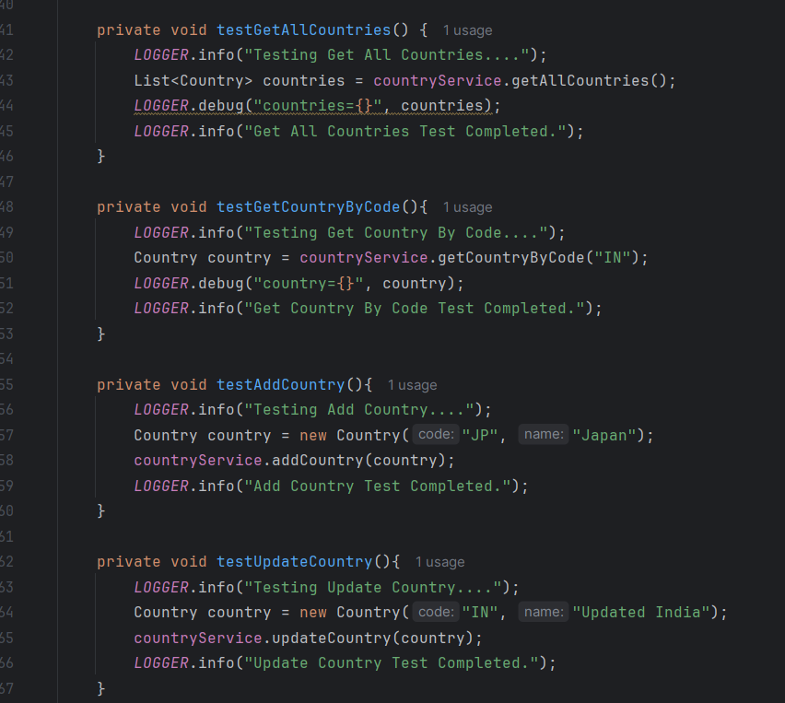

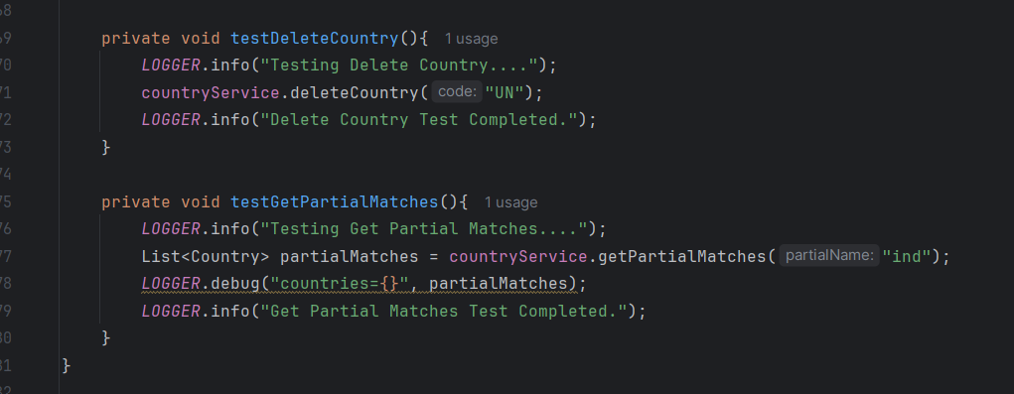

**Build & Run:**

Executed build: mvn clean package

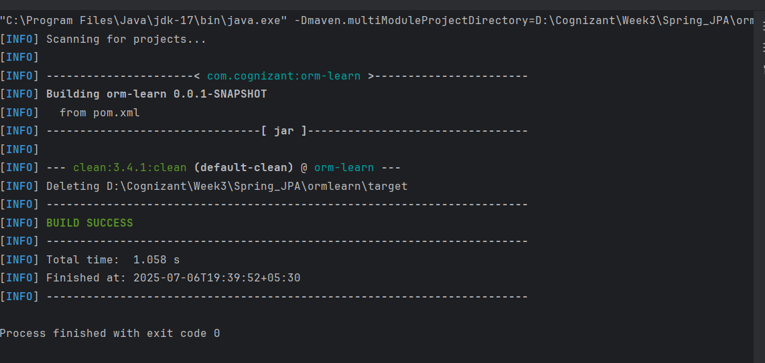

**Project Structure Overview**

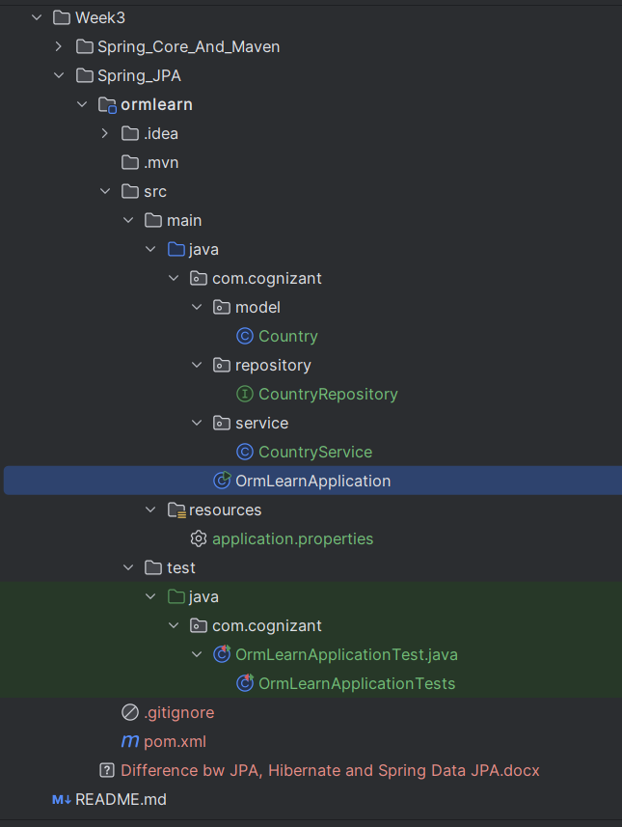

**Annotations & Configuration**

|  |  |  |  |  |  |  |  |  |  |  |
| --- | --- | --- | --- | --- | --- | --- | --- | --- | --- | --- |
| | **Component** | **Annotation / Config** | | --- | --- | | Application | @SpringBootApplication | | Entity | @Entity, @Table, @Id, @Column | | Repository | @Repository extending JpaRepository | | Service | @Service, @Transactional on service method | |